***Movie-Ticket-Booking-Console-Application***

**Introduction**

Movie Ticket Booking application it is a java console based application where in the user is allowed to signing and login after logging in the user will be shown the list of movies available to watch and then user is prompted to enter the movie name he/she is interested to watch. After entering the name this app will display the information of that entered movie name for instance show date, time, venue, available tickets, cost of tickets once the user is done with this it will prompt user if he/she wants to book the ticket or not if not then user can leave the app. Once user chooses to book the ticket this app will ask user to enter the number of seats he/she wants to book and then it will prompt user to select the seats he/she wishes to book and after selecting the seats the app will show the amount to be paid for tickets and ask user to select the payment mode from the given payment options. Once the user pays the amount successfully the tickets are booked. There is also the admin login in this application which allows admins to add new movie update the existing movie and delete the existing movie from the movie database. This Project is made for educational purpose only it covers basic concepts of core java as well as SQL.

**Technologies used**

* **Java**
* **SQL(Structured Query Language)**

**Core Java**

The Java SE is a computing-based platform and used for developing desktop or Window based applications. Thus, core Java is **the part of Java SE where the developers develop desktop-based applications by using the basic concepts of Java where JDK (Java Development Kit) is a quite familiar Java SE implementation**. In this project most of the code is written using core java even the database itself is connected to the application using the java language

**Database**

For creating database SQL Structured Query Language is used. There are 2 tables in this project one of them is movie table which stores movie details to be displayed to user and other is registration table which is used to store registration details of new user and also used to store and fetch login details of existing users. Movie table is only accessible to admin, whereas Registration table is accessible to customers/users.

**Software used**

* **Eclipse ide**

Eclipse is an integrated development environment used in computer programming. It contains a base workspace and an extensible plug-in system for customizing the environment.

* **Oracle’s SQL Developer**

Oracle SQL Developer is a free, integrated development environment that simplifies the development and management of Oracle Database in both traditional and Cloud deployments. SQL Developer offers complete end-to-end development of your PL/SQL applications, a worksheet for running queries and scripts, a DBA console for managing the database, a reports interface, a complete data modeling solution, and a migration platform for moving your 3rd party databases to Oracle.

**Output:**

Oracle:

Registration table.

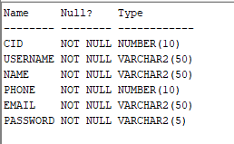

Movie table.

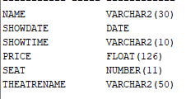

Admin

Adding movie

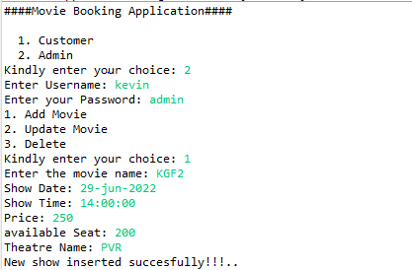



Update movie

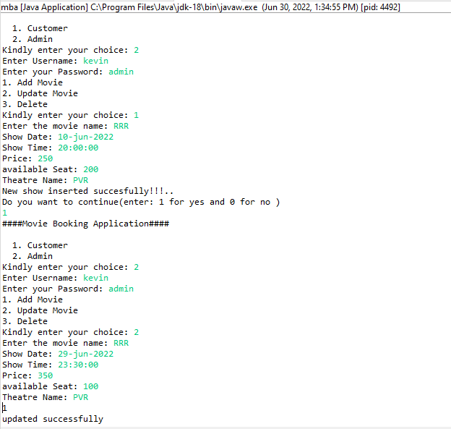

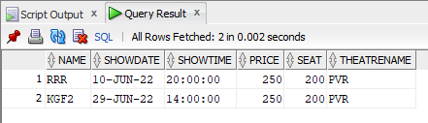



Deleting a movie from database

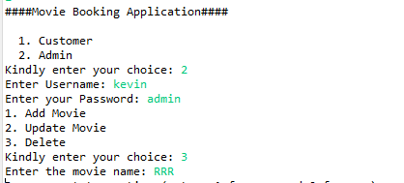





**Customer**

Signing-up, then logging-in and then Booking a movie ticket.

